Research paper

Imarsys 06

Mini project:

creating and parameterizing a small ecosystem NPZD-V model in R

course instructor(s):

Dr. Elisa Schaum

Luisa Listmann

Jana Hinners

Author:

Amirhossein Feiz

[emier.fman1997@gmail.com](mailto:emier.fman1997@gmail.com)

**S5 SuSe2021**

**1.Introduction**

We want to understand the fate of biomass produced by phytoplankton through carbon cycle when we add viral infection, zooplankton grazers or investigate how do they affect plankton population.

Phytoplankton are primary producers and they actually play an essential role in carbon cycle. so they are important because they are starting point of marine biogeochemical cycles, protistan (unicellular eukaryotic) phytoplankton have long been recognized as foundation al to fisheries and export of atmospheric CO2 to the deep ocean, (M. B. Higgins, et al 2012)( [PG Falkowski](https://scholar.google.com/citations?user=4lHobcAAAAAJ&hl=en&oi=sra) - Photosynthesis research, 1994 – Springer). Phytoplankton convert CO2 to organic carbon via photosynthesis, simultaneously altering cycles of other elements linked to carbon by the stoichiometry of cellular composition. Thus, the carbon cycle interacts with biogeochemical cycles of nitrogen, silica, and many other elements (J. P. Zehr, R. M. Kudela, Nitrogen cycle of the open ocean: From genes to ecosystems.2011). (Joseph H. Street and Adina Paytan Marine Chemistry, 2008 - Elsevier). Phytoplankton populations are controlled both by bottom up (nutrient, light, temperature) and top-down mechanisms (viral infection, zooplankton grazing) which can influence the “distribution” of biomass within an ecosystem. (H.W.Harvey et al 11 may 2009) (M. R. Landry 1984).viruses (that affect phytoplankton) are also an important factor that influences the balance of phytoplankton productivity, export production how they keep food web running and keep the food available for higher trophic levels. Also, addition to sea water of particles in the 0.002–0.2 μm size range, concentrated from sea water by ultrafiltration, reduced primary productivity ([14C] bicarbonate incorporation) by as much as 78%. These results (CA Suttle et al - Nature, 1990) (Borsheim, K. Y., *envir. Microbiool.* 1990)(Proctor, L. M. et al -*Nature* 1989) (Ian Hewson et al 2001) indicate that, in addition to grazing and nutrient limitation, infection by viruses could be a factor regulating phytoplankton community structure and primary productivity in the oceans. the quantity of virilizes is not what we know and measuring it in the way going out wild is a difficult work to be done then we look at it mathematically to investigate how rates effect this carbon cycle thus we need to create a small ecosystem model, parametrize it and run it inside the R software to follow the changes the food web with the new virilizes and grazing rates. For this purpose ( providing a mathematical look) a variety of biological models have been developed (e.g., EvansandParslow,1985; Fasham et al,1990; SteeleandHenderson,1992; HurttandArmstrong,1999; Doney et al., 1996; Moore et al., 2001). These models differ in complexity, from simple models containing three biological state variables up to more complex ones with, presently, some thirty compartments. The nitrogen-based ecosystem model developed by Fasham et al. (1990) (hereafter named FDM-model) has become a standard model used in various studies ranging from zero-dimensional mixed-layer applications to fully three-dimensional coupled ecosystem circulation models. Nitrogen-based ecosystem model, composed of four state variables (NPZD model). (M Schartau, et al- Journal of Marine Research, 2003). Basic NPZD models can show the flow of biomass through the food web levels within an ecosystem. Within the mini project, we want to add a viral component to a NPZD model and thus build a NPZD-virus model. Such a model will be the basis for i) parametrization experiments of viral lysis and grazing experiments and ii) integration into water body models of the Baltic Sea. (Garrett and Loder 1981) (Rucheng Tian et al 2015 ICES journal)

Conclusion need

**2.Material and methods**

**Equations**

dN <- - mu*P*(N/(N+kN)) + ε *N*D

dP <- mu*P*(N/(N+kN)) - I*P*V - gz*P*Z - mp*P

dV <- deltaV*I*P*V – $m_{v}$*V*D

dZ <- gz*P*Z – Z $m_{z}$* *D

dD <- $m_{p}$*P+ P*I*D + P $m_{p}$* *D + V $m_{v}$* *D - ε*N*D

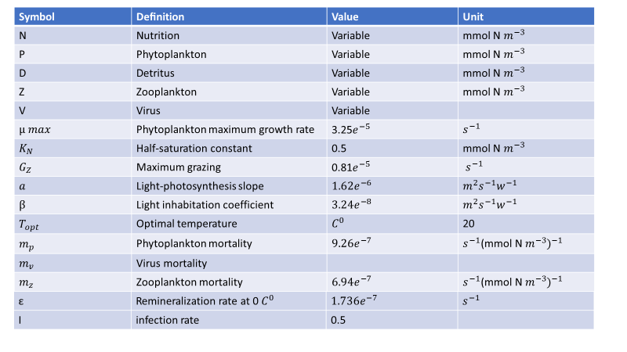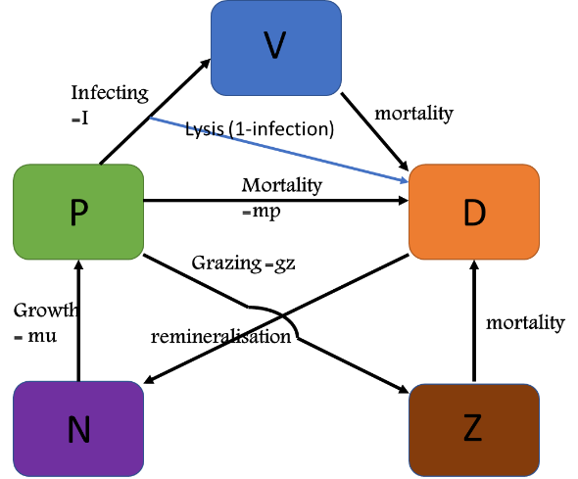**2.1. Model Deﬁnition**

Table 1. Parameter deﬁnition, values, and units of the NPZD model(**Ji et al., 2008**).

In all ecosystems there are interactions and biomass flow through the compartements each flow needs to be characterized by parameters and indicates dependence of one compartement on the other.

**2.1.1 NPZD-V diagram**

Basic NPZD models can show the flow of biomass through the basic food web levels within an ecosystem, an element of V (virus) was added to this model. In order to understand better, a diagram drew to indicate biomass flow through the compartements. This is 4-compartment nutrients-phytoplankton-zooplankton-detritus (NPZD) model plus V.

**2.3 BUILDING NPZD-V model IN R**

The experiment was conducted with the following materials: equations mentioned Parameter deﬁnition, units, and values. The initial condition of parameters was speciﬁed using the December climatological data obtained through an objective analysis (The OA was done using the software developed by Bedford Institute of Oceanography (Hendry and He, 1996)). Data sources include the National Oceanographic Data Center(www.nodc.noaa.gov), the Canadian

Figure1(Rucheng Tian et al 2015 ICES journal)

**2.1.2 equations and parameters**

The arrows in figre 1 indicate biomass flow through the compartements and for each arrows an equation is writen. Simply N🡪P means: P is dependant on N which will be indicated in the equation as P*“N“ but then needs sevaral parameters that describe the dependance.

Marine Environmental Data Service (MESD, provided by Dr Pierre Clement) and the University of Maine Database (provided by Dr Dave Townsend). Numerical method was isoda.

**3.Results**

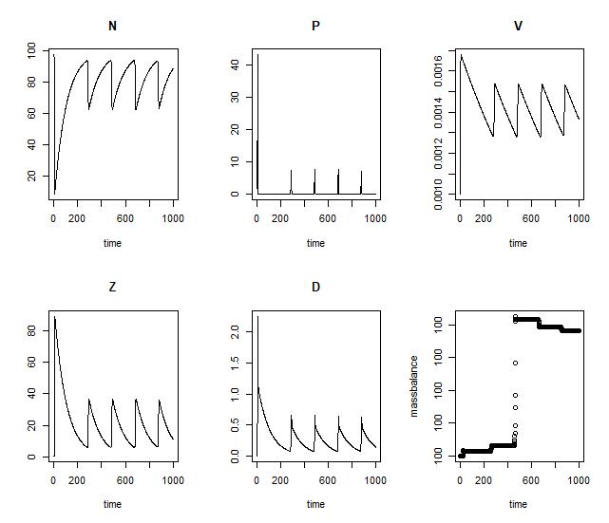

**Reference**

(M. B. Higgins, et al 2012) ( [PG Falkowski](https://scholar.google.com/citations?user=4lHobcAAAAAJ&hl=en&oi=sra) - Photosynthesis research, 1994 – Springer)

(J. P. Zehr, R. M. Kudela, Nitrogen cycle of the open ocean: From genes to ecosystems.2011). (Joseph H. Street and Adina Paytan Marine Chemistry, 2008 - Elsevier)

(H.W.Harvey et al 11 may 2009) (M. R. Landry 1984)

(CA Suttle et al - Nature, 1990) (Borsheim, K. Y., *envir. Microbiool.* 1990)(Proctor, L. M. et al -*Nature* 1989) (Ian Hewson et al 2001)

(e.g., EvansandParslow,1985; Fasham et al,1990; SteeleandHenderson,1992; HurttandArmstrong,1999; Doney et al., 1996; Moore et al., 2001)

(M Schartau, et al- Journal of Marine Research, 2003)

(Garrett and Loder 1981) (Rucheng Tian et al 2015 ICES journal)

(Hendry and He, 1996). Data sources include the National Oceanographic Data Center (www.nodc.noaa.gov), the Canadian Marine Environmental Data Service (MESD, provided by Dr Pierre Clement) and the University of Maine Database (provided by Dr Dave Townsend)